Task5:

Q: Given an array nums containing n distinct numbers in the range[0,n] return the only number in the range that is missing from the array.

**Analysis:**

* First find the formula for missing num
* Next using for of loop
* (Sn)=n(n+1)/2 use this formula for find the missing num
* Next take a array of three values [3,0,1]
* 3*4/2=6
* Total array length 3(n) and add n+1(4) divided by 2
* (Sa)= 3+0+1=4
* Sn – Sa
* 6 – 4
* Result (2)

**Flow chart:**

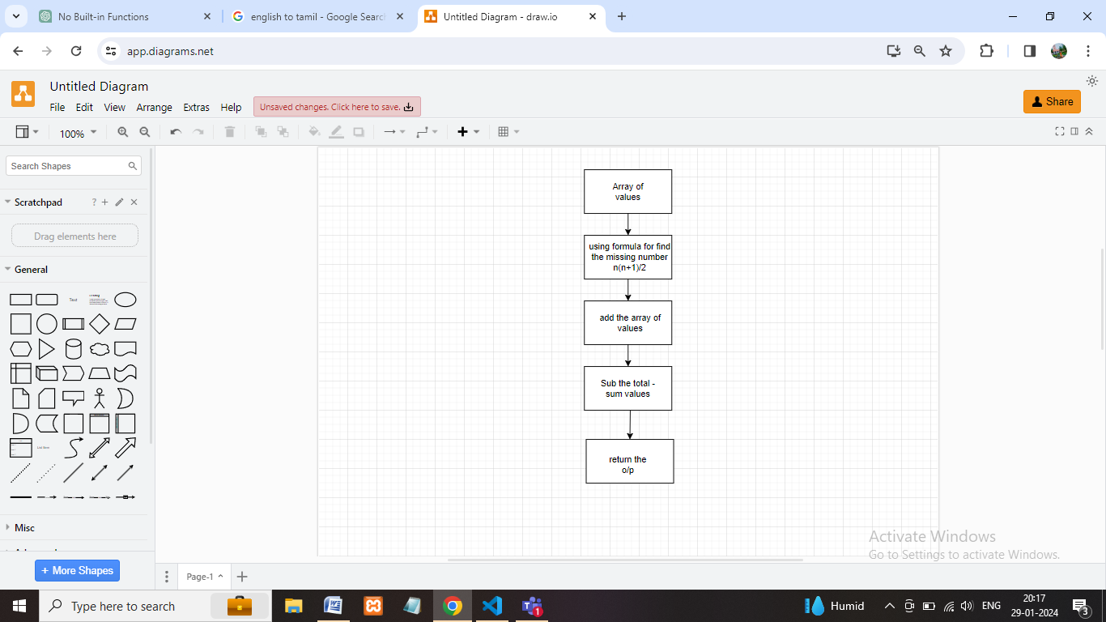

**Coding:**

let number = [3, 0, 1];

let total = (3 / 2) * (3 + 1); //(n * (n + 1)) / 2) //6

let n = 0; //4

for (num of number) {

n = n + num;//array of 3+0+1=4

}

console.log("missing value is:", (total - n)); //6 - 4 =2

**Output:**

